

**Digital Image Processing (CSE-438)**

**Sec:03**

**Lab: 04**

**Submitted to:**

Md. Asif Khan Rifat

Lecturer  
Department of Computer Science & Engineering

East West University

**Submitted by:**

Prinom Mojumder

2021-2-60-098

1. Sharpen the following image by applying the following and find out which one is better:

a) Unsharp Masking

Code:

original = imread('Picture1.jpg');

original = im2double(original); % Convert to double

if size(original, 3) == 3

original_gray = rgb2gray(original);

else

original_gray = original;

end

h = fspecial('gaussian', [5 5], 1); % Gaussian blur kernel

blurred = imfilter(original_gray, h, 'replicate');

mask = original_gray - blurred;

unsharp_img = original_gray + mask;

figure('Name','Unsharp Masking Result','NumberTitle','off');

subplot(1, 2, 1);

imshow(original_gray);

title('Original Image');

subplot(1, 2, 2);

imshow(unsharp_img);

title('Unsharp Masked Image');

Output:

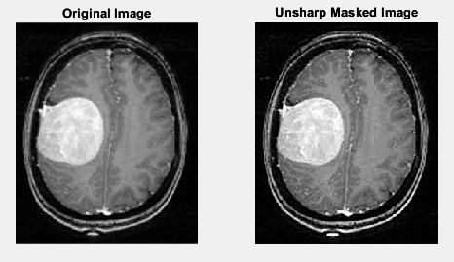

b) High Boost Filtering

Code:

original = imread('Picture1.jpg');

original = im2double(original);

if size(original, 3) == 3

original_gray = rgb2gray(original);

else

original_gray = original;

end

h = fspecial('gaussian', [5 5], 1);

blurred = imfilter(original_gray, h, 'replicate');

mask = original_gray - blurred;

A = 1.5;

high_boost_img = original_gray + A * mask;

figure('Name','High Boost Filtering','NumberTitle','off');

subplot(1, 2, 1);

imshow(original_gray);

title('Original Image');

subplot(1, 2, 2);

imshow(high_boost_img);

title(['High Boost Image (A = ', num2str(A), ')']);

Output:

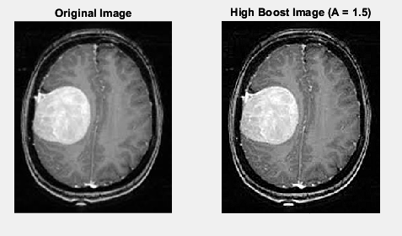

2. Sharpen the following image using the concept of Laplacian Filtering.

Code:

original = imread('Picture2.jpg');

original = im2double(original);

if size(original, 3) == 3

original_gray = rgb2gray(original);

else

original_gray = original;

end

laplacian_filter = fspecial('laplacian', 0.2);

laplacian_img = imfilter(original_gray, laplacian_filter, 'replicate');

sharpened_img = original_gray - laplacian_img;

figure('Name','Laplacian Filtering','NumberTitle','off');

subplot(1, 2, 1);

imshow(original_gray);

title('Original Image');

subplot(1, 2, 2);

imshow(sharpened_img);

title('Laplacian Sharpened Image');

Output:

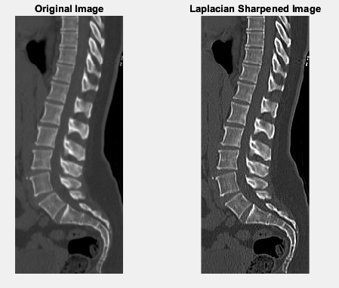

3. Use Roberts-cross, Sobel, and Prewitt operators to detect the edge of the following

image.

Code:

original = imread('Picture3.jpg');

original = im2double(original);

if size(original, 3) == 3

original_gray = rgb2gray(original);

else

original_gray = original;

end

edge_roberts = edge(original_gray, 'roberts');

edge_sobel = edge(original_gray, 'sobel');

edge_prewitt = edge(original_gray, 'prewitt');

figure('Name','Edge Detection using Different Operators','NumberTitle','off');

subplot(2, 2, 1);

imshow(original_gray);

title('Original Image');

subplot(2, 2, 2);

imshow(edge_roberts);

title('Roberts Operator');

subplot(2, 2, 3);

imshow(edge_sobel);

title('Sobel Operator');

subplot(2, 2, 4);

imshow(edge_prewitt);

title('Prewitt Operator');

Output:

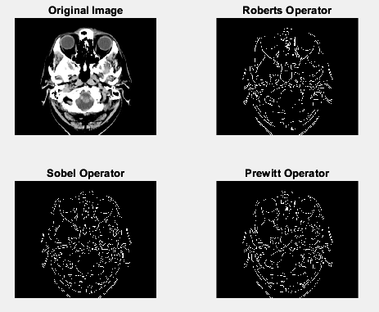

4. Show performance comparison among High Boost, Unsharp, Laplacian Roberts-cross, Sobel, Prewitt and Canny filtering for edge detection – find out which one is better for the given image.

Code:

original = imread('Picture3.jpg');

original = im2double(original);

if size(original, 3) == 3

original_gray = rgb2gray(original);

else

original_gray = original;

end

h = fspecial('gaussian', [5 5], 1);

blurred = imfilter(original_gray, h, 'replicate');

mask = original_gray - blurred;

unsharp_img = original_gray + mask;

unsharp_sobel = edge(unsharp_img, 'sobel');

A = 1.5;

high_boost_img = original_gray + A * mask;

highboost_sobel = edge(high_boost_img, 'sobel');

laplacian_filter = fspecial('laplacian', 0.2);

laplacian_img = original_gray - imfilter(original_gray, laplacian_filter, 'replicate');

laplacian_sobel = edge(laplacian_img, 'sobel');

edge_roberts = edge(original_gray, 'roberts');

edge_sobel = edge(original_gray, 'sobel');

edge_prewitt = edge(original_gray, 'prewitt');

edge_canny = edge(original_gray, 'canny');

figure;

subplot(3, 3, 1); imshow(original_gray); title('Original');

subplot(3, 3, 2); imshow(unsharp_sobel); title('Unsharp + Sobel');

subplot(3, 3, 3); imshow(highboost_sobel); title('High Boost + Sobel');

subplot(3, 3, 4); imshow(laplacian_sobel); title('Laplacian + Sobel');

subplot(3, 3, 5); imshow(edge_roberts); title('Roberts');

subplot(3, 3, 6); imshow(edge_sobel); title('Sobel');

subplot(3, 3, 7); imshow(edge_prewitt); title('Prewitt');

subplot(3, 3, 8); imshow(edge_canny); title('Canny');

Output:

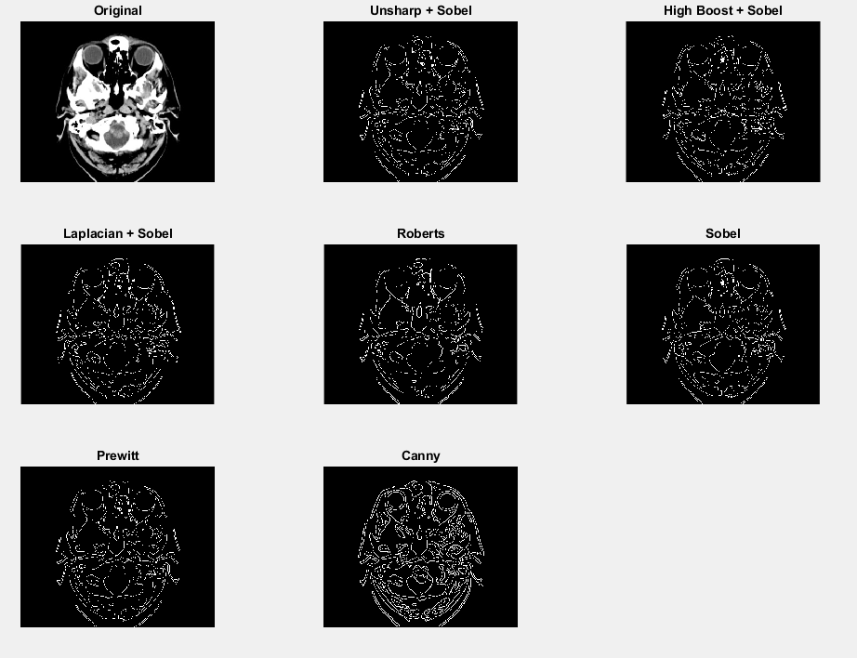

**Observation:**  
Canny

* Best overall: clean, accurate, continuous edges.
* Includes Gaussian smoothing → low noise.
* High performance for object boundaries.